**Name-Tushar Chaudhary**

**Roll number- 2100290310152**

**Section-C**

**EXPERIMENT NO:-5**

***OBJECTIVE:*** Create the state space model of a linear continuous system.

***SOFTWARE REQUIRED:*** MATLAB 2022

***THEORY:***

Creating a state space model of a linear continuous system involves representing the system using state variables, input variables, output variables, and state equations.

In a linear continuous system, the state space representation is given by the following set of equations:

State equation: 𝑥(𝑡)=𝐴𝑥(𝑡)+𝐵𝑢(𝑡)

Output equation: 𝑦(𝑡)=𝐶𝑥(𝑡)+𝐷𝑢(𝑡)

Where:

𝑥(𝑡) represents the state vector, which contains the system's internal variables that describe its current state.

𝑢(𝑡) is the input vector that affects the state evolution.

𝑦(𝑡) is the output vector that represents the system's response to inputs.

𝐴 is the state matrix that describes how the state variables change over time.

𝐵 is the input matrix that relates inputs to state changes.

𝐶 is the output matrix that relates state variables to outputs.

𝐷 is the feedforward matrix that directly relates inputs to outputs.

***Block Diagram Representation of Linear Systems Described by State Equations***

***MATLAB Code:***

clear all

clc

A = [0 1;-5 -2];

B = [0;3];

C = [0 1];

D = 0;

E =[0 1; 1 1];

Ts = 0.25;

sys = ss(A,B,C,D)

step(sys)

***Result***:

1. Continuous-time state-space model.

Command Window: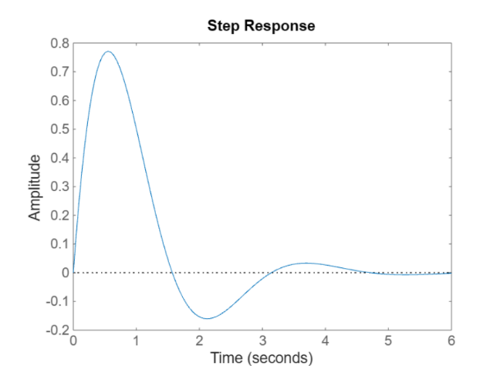

2.Discrete-time state-space model.

Clear all

clc

A = [0 1;-5 -2];

B = [0;3];

C = [0 1];

D = 0;

E =[0 1; 1 1];

Ts = 0.25;

sys = ss(A,B,C,D,Ts)

step(sys)

Clear all

clc

A = [0 1;-5 -2];

B = [0;3];

C = [0 1];

D = 0;

E =[0 1; 1 1];

Ts = 0.25;

sys = ss(A,B,C,D,Ts)

sysFeedback = feedback(sys,1);

P = pole(sysFeedback)

rlocus(sys)

***Applications:***

***Control Systems:*** State space models are widely used in control engineering for designing controllers, such as state feedback controllers and observers. These models allow engineers to analyze and optimize system behavior.

***System Analysis:*** State space models facilitate system analysis by providing insights into stability, controllability, and observability. Engineers can analyze the system's behavior under different conditions and make informed decisions.

***Estimation and Filtering:*** State space models are used in estimation and filtering techniques like Kalman filters. These methods help in estimating the system's states based on noisy measurements, enhancing the system's reliability and accuracy.

***Robotics and Autonomous Systems:*** State space models are essential in robotics for modeling robot dynamics, trajectory planning, and sensor fusion. They enable precise control and navigation in complex environments.

***Electrical Engineering:*** In electrical systems, state space models are used to analyze and design circuits, control systems, and power systems. They play a crucial role in optimizing performance and efficiency.